Problem #1: A Cat, a Parrot, and a Bag of Seed

**Define The Problem**

The problem at hand is that there is a man who needs to cross a river. However, he has an issue. Two animals, a cat and a parrot, accompany this man. The man is also carrying a bag of seed. To get across the river the man has a boat but it can only carry him and one of these three. The man cannot leave the cat and bird alone, because the cat could eat the bird. On the other hand he can’t leave the bird with the seed, because the bird would eat the seed.

Somehow, the man needs to be able to get both animals and the seed over the river without leaving the wrong animals together. However, the problem never says anything about not leaving the cat and the seed together. It also does not state that the parrot is in a cage or that it cannot fly for any reason. If the bird is in a cage, they cat could not eat the parrot.

**Break the Problem Apart**

The constraints of the problem are as such:

* The cat **could** eat the parrot.
* The parrot and the seed cannot be left together
* Only one can fit in the boat with the man.

The sub-goals are the following:

* Don’t leave the cat with the bird.
* Don’t leave the seed with the bird.
* Only one other “item” an go in the boat with the man.

**Identify Potential Solutions**

Sub-goal #1: Don’t leave the cat with the bird.

* Possible solution to this is to take the bird over first. This would eliminate the possibility of leaving the cat and bird alone on the riverbank.
* Another solution would be to take the cat over first. This would also keep the two animals from being alone.

Sub-goal #2: Don’t leave the bird and the seed alone.

* Take the seed over first. This would keep the bird from eating the seed.
* Take the bird over so the parrot cannot eat the seed.

Sub-goal #3: Get each over without having more than one in the boat with then man.

* You could allow the bird to fly over to the other side of the river.
* Could have the bird sit on the man’s shoulder while he takes the seed or the cat over to the other side.

**Evaluate Each Potential Solution**

* Take the cat over first
  + If he takes the cat over first, the bird then could eat the seed. This is not a possible situation.
* Take the bird over first
  + If the bird is taken over first, then they cat would not eat the bird, and the cat would not eat the seed.
* Take the seed over first
  + If you take the seed over first, the cat could eat the bird. This would not be a possible solution.
* Have the bird fly over
  + The bird could fly over. This is a very possible solution. This is possible because there is no way that the man carried the bird if he is carrying the seed. Therefore the bird would follow the man across the river.
* Have the bird ride on the man’s shoulder
  + The problem only states that there is room for the man and one item ***in*** the boat. Why could the man not carry the bird on his shoulder? Therefore, the man could take the bird on his shoulder, and then put either the cat or the seed in the boat. The bird could stay on his shoulder on the trip back to get the last thing needed and then everything would be on the other side of the river.

**Choose a Solution and Develop a Plan to Implement It**

Problem #2 Socks in the Dark

**Define the Problem**

The problem is that someone has unmatched socks in a drawer and no light available. They have 10 black socks, 6 brown socks, and 4 white socks. The questions posed are:

* What is the minimum number of “pairs” needed to be selected to get **one** matching pair?
* What is the minimum number of “pairs” needed to be selected to get one matching pair of each color?

When I first read this problem, I had flashbacks of probability problems in math class. However after reading it a few times, there is nothing in the problem stating two major questions. First, do you have to put both socks back? Secondly, what is stopping you from putting socks in a specific area after you put them back after checking them?

**Break the Problem Apart**

As I look at the problem, there is one main constraint. That is that you have to choose being in the complete dark and not check until after a pair has been selected. The sub-goals are to use the minimum number of attempts to be guaranteed a matching pair, as well as to find the minimum number of attempts to get one of each color.

**Identify Potential Solutions**

The first solution is to keep a sock out each time.

The second solution is to separate the socks as you go.

**Evaluate Each Potential Solution**

1. Keeping a sock out each time.
   1. By keeping a sock out each time, you could get a match easily. For example if you get a black and white sock, keep the black one out because you have a better chance of getting a black one.
   2. Then if you get a brown and white the next time, keep the brown sock.
   3. Finally, you have two possibilities and with there only being 4 white socks, there is a high probability of having a match after 3 but a guaranteed after 4 “matches.”
2. Separating socks in the drawer as you go.
   1. By separating the socks, you would have a guaranteed match after 3 “matches”

**Choose a Solution and Develop a Plan to Implement It**

The solution I chose was to separate the socks in the drawer. This is the most efficient way to do this. Since you can check after each “match” you can see what you have.

Say for the first “match” you get a black and white sock. You can then have your drawer arranged, in theory, like so:

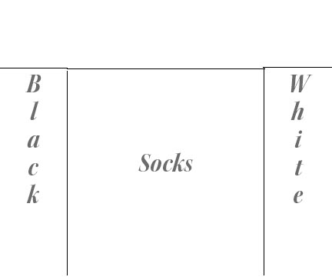

You then have one black sock and one white sock that you **know** where they are. Therefore, after your next selection, which could be a brown and black sock, you then have a drawer looking like this:

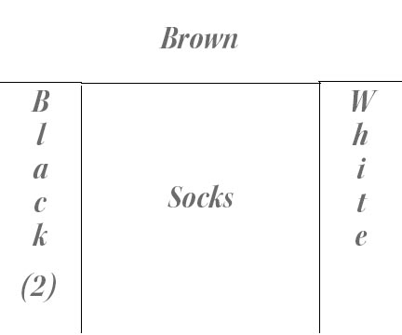

Therefore, you can choose the two black socks and have a guaranteed matching pair in 3 selections.

As far as the second sub-goal, this is a bit trickier. You would have to continue on. The minimum number of selections needed to have a pair of each guaranteed would be 5. If you pulled out a brown and a black sock, you would then have the following:

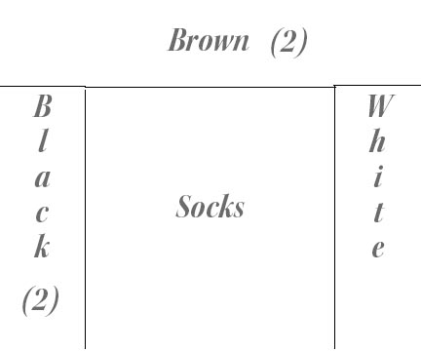

Finally if you choose a black and a white one on the 5th selection, you would then have :

